TASK 1

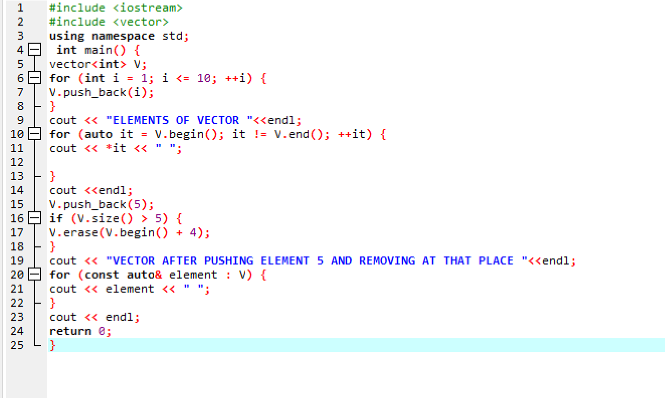

TASK 2

#include <iostream>

#include <vector>

using namespace std;

int mean(vector<int> vec){

int sum=0, size=vec.size();

for(int i=0; i<vec.size(); i++){

sum=vec[i]+sum;

}

int mean=sum/vec.size();

return mean;

}

int median(vector<int> vec){

int i, j, temp, median;

for(i=0; i<vec.size()-1; i++){

for(j=0; j<vec.size()-1; j++){

if(vec[j]>vec[j+1]){

temp=vec[j];

vec[j]=vec[j+1];

vec[j+1]=temp;

}

}

}

int n=vec.size();

if(n%2 == 0){

median=((n/2)+((n/2)+1))/2;

}

else{

median=(n+1)/2;

}

return vec[median-1] ;

}

int mode(vector<int> vec){

int repetition=0, maxrep=0, mostrepeated;

for(int i=0; i<vec.size(); i++){

repetition=0;

for(int j=0; j<vec.size(); j++){

if(vec[i]==vec[j]){

repetition++;

}

}

if(repetition>maxrep){

maxrep=repetition;

mostrepeated=vec[i];

}

}

return mostrepeated;

}

void students_mode(vector<string> vec, vector<int> vec2, int mode){

int i=0;

cout<<"Students with Grade Equal to Mode value: ";

for(i=0; i<vec.size(); i++){

if(vec2[i]==mode){

cout<<vec[i]<<" ";

}

}

}

int main(){

vector<string> names;

vector<int> grades;

int i,j,input,num,Mean,Median,Mode;

string name;

cout<<"NUMBER OF STUDENTS : ";

cin>>num;

for(i=0; i<num; i++){

cout<<"NAME : ";

cin>>name;

names.push_back(name);

cout<<endl<<"ENTER THE GRADE PERCENTAGE ";

cin>>input;

grades.push_back(input);

}

Mean=mean(grades);

cout<<endl<<"MEAN "<<Mean<<endl;

Median=median(grades);

cout<<"MEDIAN "<<Median<<endl;

Mode=mode(grades);

cout<<"MODE "<<Mode<<endl;

students_mode(names, grades, Mode);

}

